# Final Project Description

---By Miaoting Feng

## Overview

I build up my website using Bootstrap 4.0.

### Index

My main page contains header, footer, contents and navigation. It shows below:

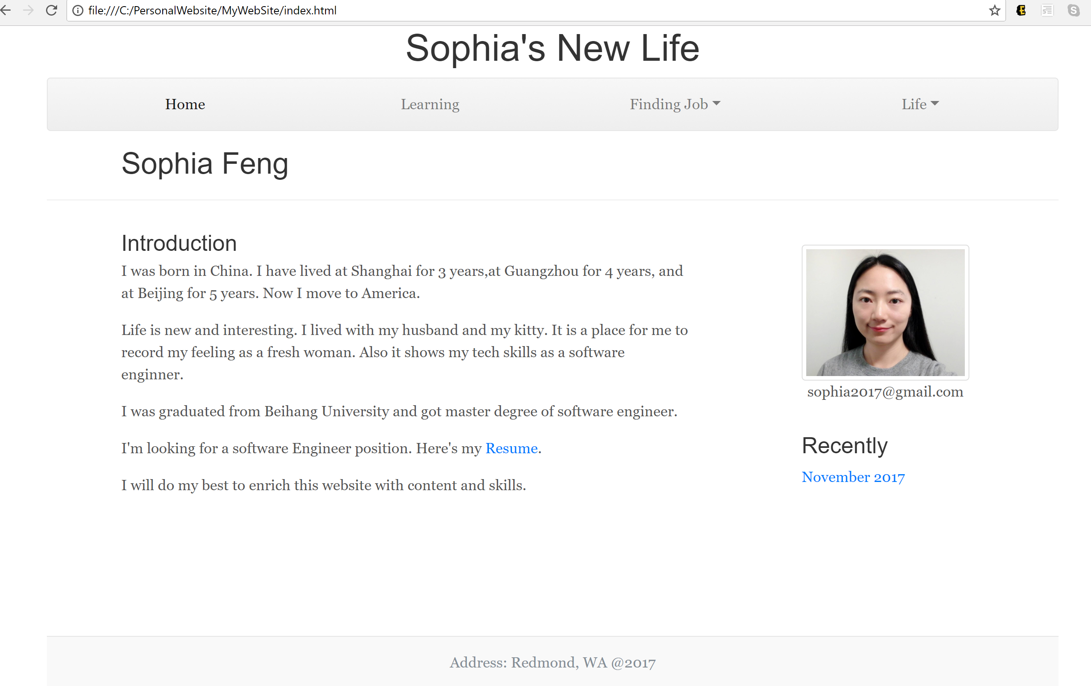

### Learning

The learning page shows my recent study achievements with Carousel.

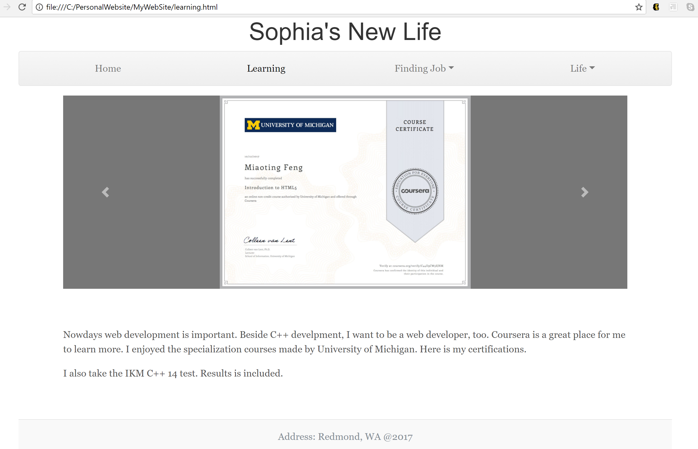

### Finding job

It is a link to my resume. And its format is PDF.

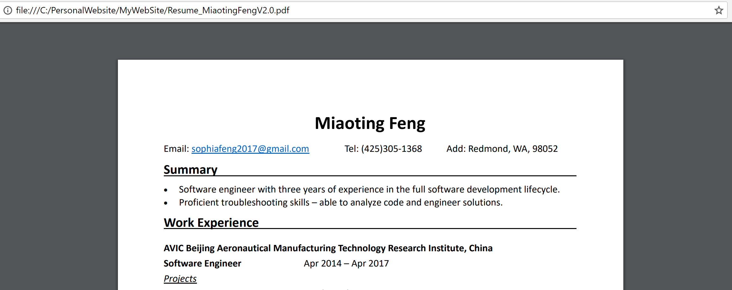

### Life

It contains two pages. One is about my family. Some pictures are use light box to display. The footer is a stick one. And the other is a place to tell my feeling about new life. It is like a blog. Also, it contains google calendar to help us look out the date.

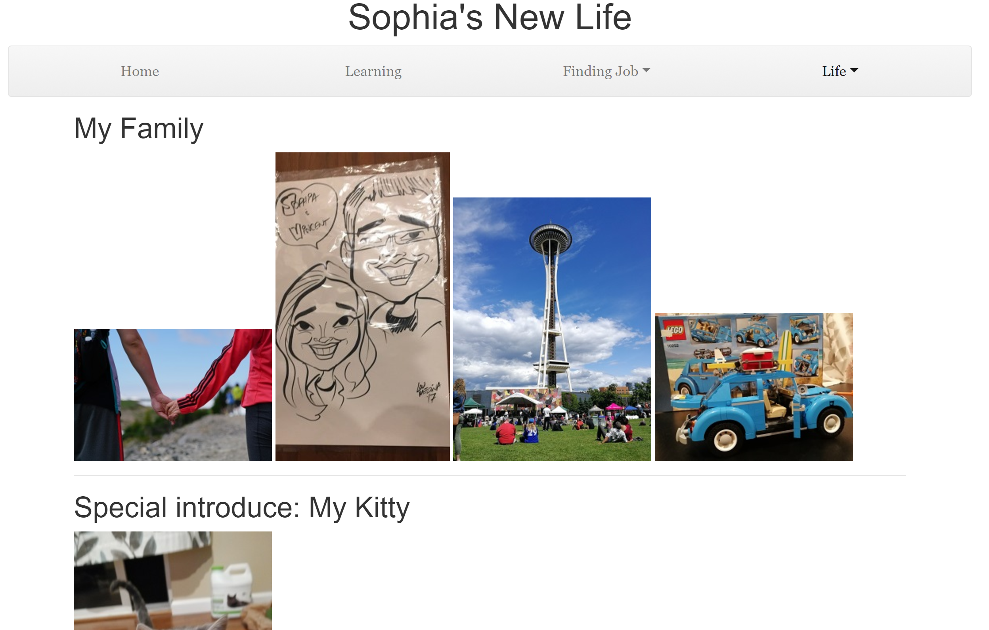

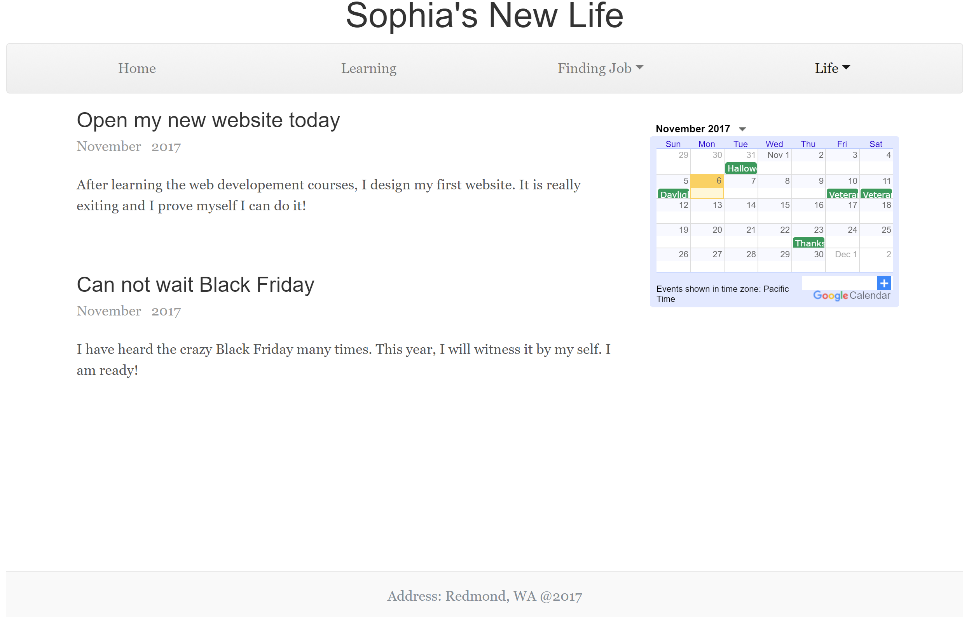

## W3 validator compliant

I use validator by upload files. It is 4 pages totally. The result finally shows the pages are good.

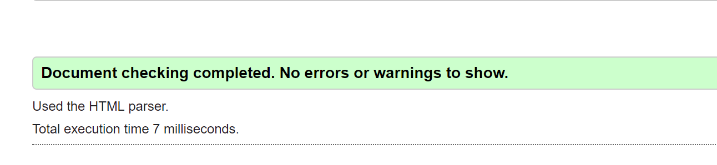

## Responsive

I designed the website looks different when use small screens. The index page does not my photos and a toggleable off-canvas navigation menu was built by Bootstrap.

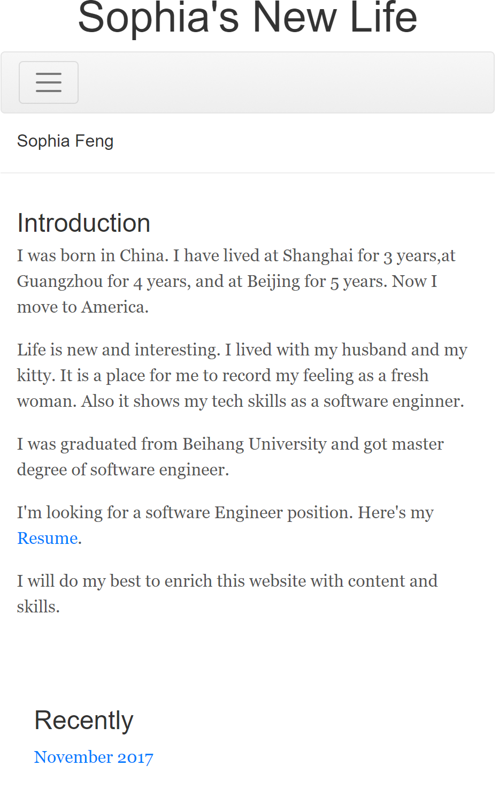

Also, the google calendar on the feeling page is gone.

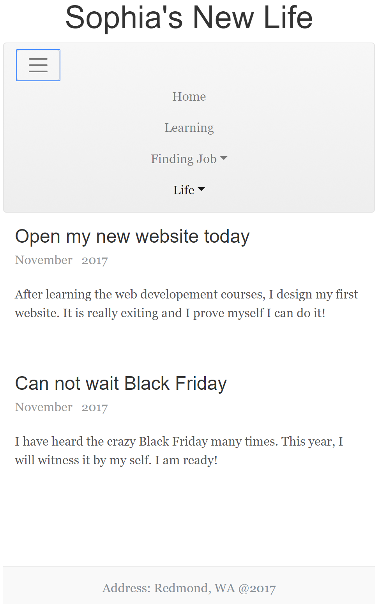

## Well-styled

Besides bootstrap.css and lightbox.css which I use to build the website, I also create my style.css.

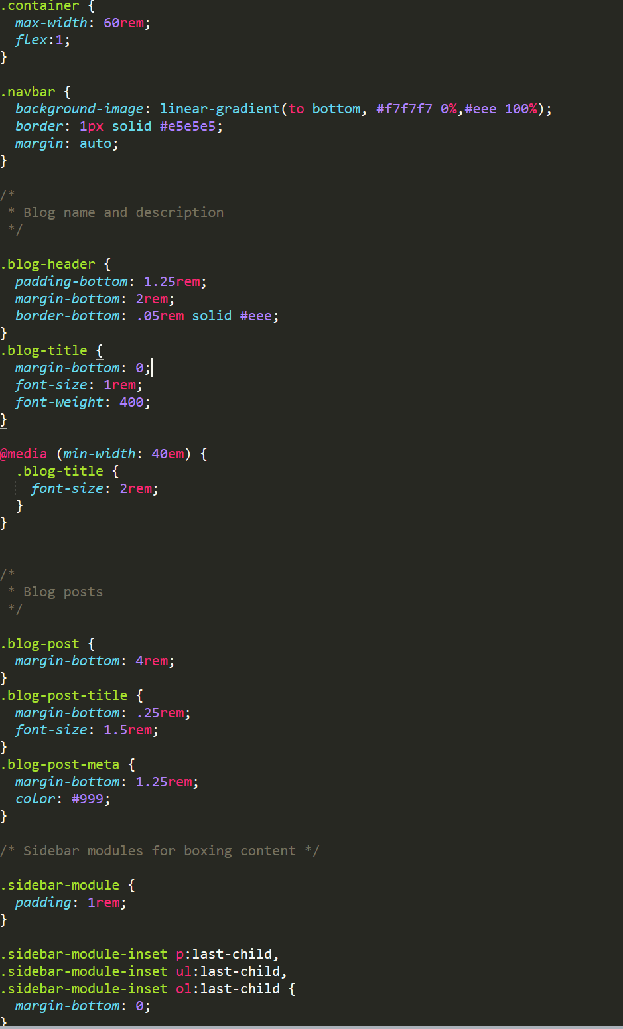

## Extras

### Sticky Footer

The footer is stick to bottom.

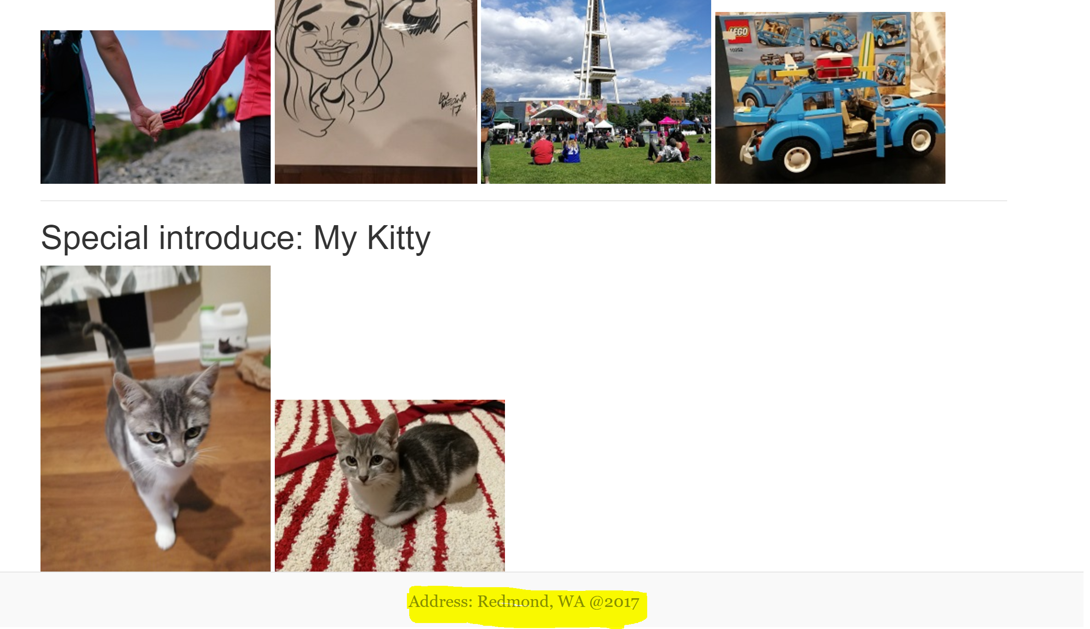

### Google Calendar

You can find it above. It is on picture of the feeling page.

### Bootstrap Carousel

You can find it above. It is on picture of the learning page.

### LightBox Plugin

It is on my family page, and helps me show pictures of my family.

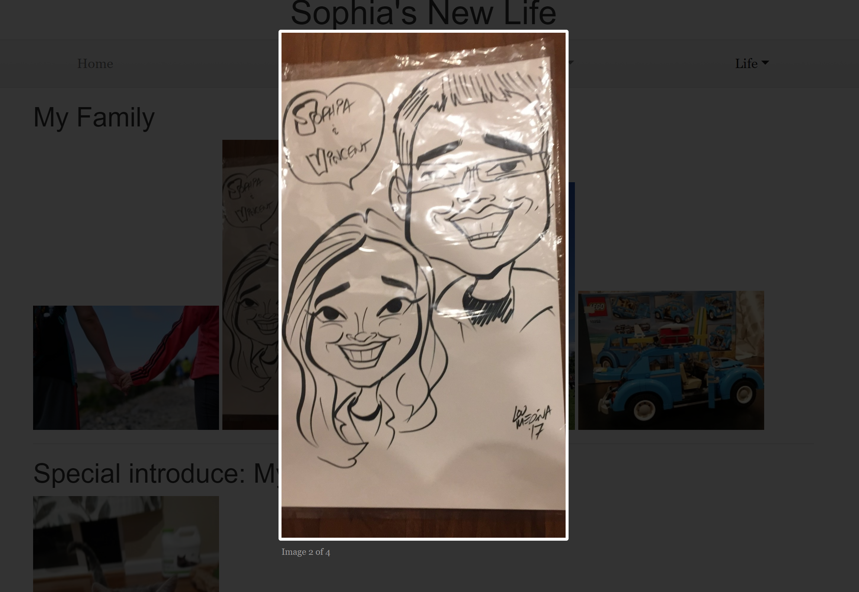

The show is over. Thanks for your time!